Candidate Rate Submission Overview

When submitting a candidate for consideration for the Idaho IT Vendor Managed Services contract, you will be asked to enter the Vendor Rate (the rate that will be paid to your company should your candidate be selected) and the Vendor Rate + $2.68 NASPO Fee (the rate that will be paid to your company, plus the $2.68 NASPO fee for administering the contract).
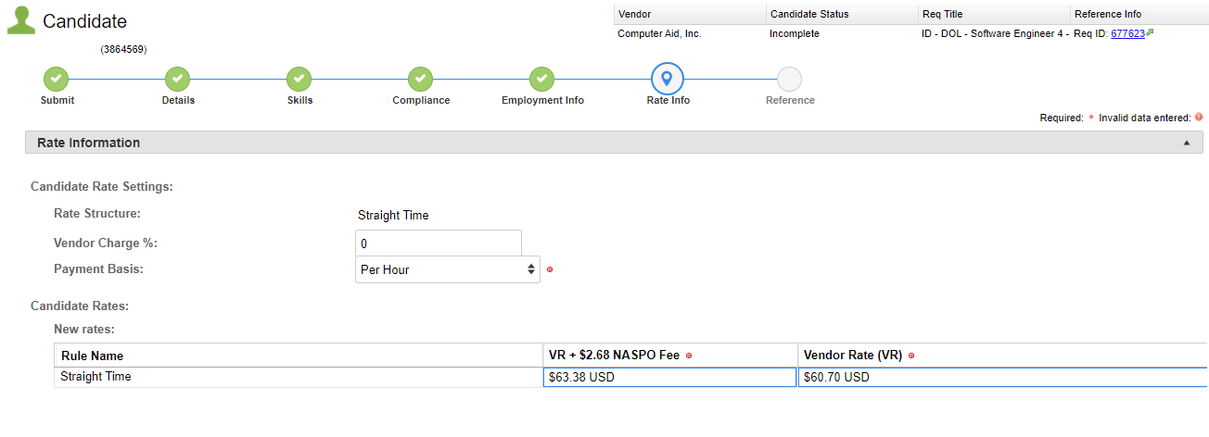
The screenshots below show how these fields are shown on the candidate profile:

When submitting a candidate:
- Enter the Vendor Rate (VR) that your company wishes to be paid for the candidate
  - Please note: this rate must be at or below the not-to-exceed Vendor Rate specified within the Questions section of the Requisition.
- Within the VR + $2.68 NASPO Fee field, add $2.68 to the Vendor Rate that you entered. This rate includes the NASPO contract fee.
During the screening process, CAI will review the entered rates for correctness and will contact you if changes need to be made.

If you have additional questions regarding the submission process, please contact the CAI Account Manager associated with the requisition.

